Example 3
A ball at 1200K is allowed to cool down in air at an ambient temperature of 300K. Assuming heat is lost only due to radiation, the differential equation for the temperature of the ball is given by
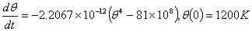
Find the temperature at seconds using Runge-Kutta 4th order method. Assume a step size of seconds.
Solution
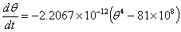
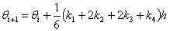
For , ,
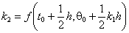
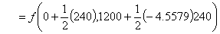
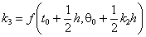
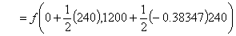
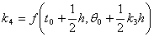
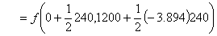
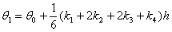
is the approximate temperature at
For
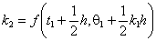
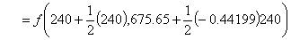
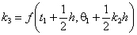
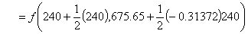
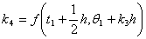
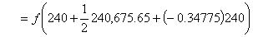
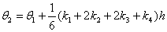
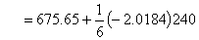
is the approximate temperature at
=
Figure 1 compares the exact solution with the numerical solution using Runge-Kutta 4th order method step size of h=240.

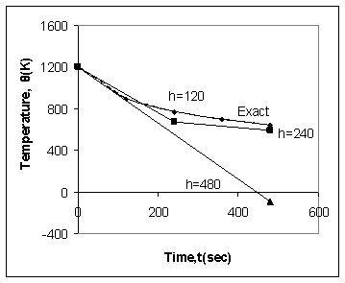
Figure 1. Comparison of Runge-Kutta 4th order method with exact solution for different step sizes

